**BONAFIDE CERTIFICATE**

This to certify that the report entitled

**Application Deployment On AWS ECS**

**Service Using CI/CD Tool**

being submitted to the University of Madras, Chennai.

**By**

**V.T DHAMODARAN**

(Reg.No. No:811850046)

for the portal fulfilment for the award of degree of

**MASTER OF COMPUTER APPLICATIONS**

Is a bonafide record work TCried out by him under the guidance and supervision.

Date:

**Mr. D. RAVANDOSS.,** M.c.A.,M.Phil.,

Assistant Professor, Department of Computer Applications, Jaya College of Arts and Science, Thiruninravur-602 024.

Submitted for the viva-voice examination held on

**Internal Examiner External Examiner**

**DECLARATION**

This is to certify that the project entitled **"Application Deployment On AWS ECS**

**Service Using CI/CD Tool"** submitted to the University of Madras in partial fulfillment of the requirements for the degree of **MASTER OF COMPUTER APPLICATIONS** is a record of original main project work done by me, under the guidance and supervision of **Mr. D. RAVANDOSS.,M.C.A.,M.Phil. Assistant Professor,** Department of Computer Applications, Jaya College of Arts & Science, Thiruninravur - 602024, and it has not form the basis for award of degree nor similar title to any candidate of any university.

**V.T DHAMODARAN**

Reg.No:- 811850046 MASTER OF COMPUTER APPLICATIONS, JAYA COLLEGE OF ARTS AND SCIENCE,

THIRUNINRAVUR - 602024.

# ACKNOWLEDGEMENT

The Project work cannot be a one-man show. Although it is impossible to give individual thanks to all helpful faculty members and to those in connection. I take this opportunity to express my gratitude for them.

As a start, my heartfelt thanks to God for giving his blessing and confidence to make this project a successful one.

I feel grateful to thank **Prof. A.KANAGRAJ, M.A.,M.Phil.,** Founder and Chairman, Jaya Educational Trust, **Mrs. K. VIJAYAKUMAI.M.A.,B.ED.,** Secretary,Jaya EducationalmTrust, and **Mr. K. NAVARAJ,M.E.,** Vice Chairman,Jaya Educational Trust for extending their support during course of my studies .

I am grageful to **Dr. P.GUHAN, M.C.A., M.Phil., Ph.D.,** prin cipal, Jaya College of Arts and Science, Thiruninravur - 602 024, for providing me with an environment to complete my project successfully.

I take pleasure in thanking **Mrs. S. Cynthia Juliet.,M.C.A.,M.Phil. Head Of The Depertment(i/c),** Department of Computer Applications, Jaya College of Arts and Science, Thiruninravur, for extending his support throughout the main project.

I would also thank my Institution and faculty members without whom this project would have been a reality.

By

# V.T DHAMODARAN

(Reg. No.: 811850046)

**Application Deployment On AWS ECS**

**Service Using CI/CD Tool**

**INDEX**

|  |  |  |
| --- | --- | --- |
| S.No. | CONTENTS | Page No. |
| 1 | **ABSTRACT** | 5 |
| 2 | **SYSTEM ANALYSIS AND DESIGN** | 8 |
|  | 2.1 Existing System |  |
| 2.2 Proposed System |  |
| 2.3 Hardware Requirements |  |
| 2.4 Software Requirements |  |
| 3 | **PROJECT DESIGN** | 20 |
|  | 3.1 Data Flow Diagram |  |
| 4 | **FRONT DESIGN** | 23 |
| 5 | **SOURCE CODE** | 29 |
| 6 | **REPORT** | 40 |
| 7 | **DEPLOY END** | 42 |
| 8 | **SYSTEM TESTING** | 45 |
| 9 | **CONCLUSION** | 54 |
| 10 | **BIBLIOGRAPHY** | 55 |

**ABSTRACT**

### Deploy Software Application Using CI/CD Tools:

Jenkins is a self-contained, open source automation server which can be used to automate all sorts of tasks related to building, testing, and delivering or deploying software.

Jenkins can be installed through native system packages, Docker, or even run standalone by any machine with a Java Runtime Environment (JRE) installed.

A Docker container is an open source software development platform. Its main benefit is to package applications in containers, allowing them to be portable to any system running a Linux or Windows operating system (OS). A Windows machine can run Linux containers by using a virtual machine (VM). Container technology has been around for a while, but momentum and hype around Docker’s approach to containers have pushed this approach to the forefront.

While it is a major player in the container field, Docker is only one form of container technology. Read this SDxCentral article to learn how Docker containers work.

The project **SIGHT DREAM SERVICES** was developed as a customized Software initially. And Deploy using Docker and CI/CD Tool Technologies.

This sight dream services project developed using PHP programming language. The main aim of this project is to deploy continuous integration and continuous delivery to simplify the software development life cycle process. I’m using AWS EC2/ECS for building a container deploying application on ECS service.

#### Project developed using:

Develop End:

* Project Designed using HTML,JAVASCRIPT,CSS.
* Project Code developed using PHP programming language.

Deploy End:

* Project Deployed using Docker container Software.
* CI/CD tool for Continuous integration/delivery.
* SCM used for Code Repository.
* AWS ECS/EC2 Services for Build and deploy Application.

#### Following are the modules of the project:

* + - * About module

1. Team
2. Partner
   * + - Service module
3. IT consulting
4. IT support
5. IT Services
6. Manpower
   * + - Product and Solutions module
7. Web Development
8. Mobile Development
9. Cloud Development
10. Digital Marketing Services
    * + - Career Module
        - Contact Module

# SYSTEM ANALYSIS AND DESIGN

* 1. **Existing System**

**I**n existing technologies the administrators will deploy the application manually.

If we have less number of application can we deploy manually.

if we have 50**+** application it’s big challenge to deploy the application in manually.

In existing technology they use VM’s Technology. In VM’s Technology concept we cant deploy the application fraction of seconds. It takes time to deploy applications.

## Proposed System:

The proposed system, Deploy the applications using CI/CD Tool which is deployed automatically when committee happens in SCM repository.

when we you CI/CD tool it will automatically pull the code and compile the code and deploy the code on servers.

When you use this technologies we can simplify the application development life cycle.

We can also reduce the time off application deployment.

## ADVANTAGES:

when we you CI/CD tool it will automatically pull the code and compile the code and deploy the code on servers

Project Deployed using Docker container Software.

CI/CD tool for Continuous integration/delivery.

SCM used for Code Repository.

AWS ECS/EC2 Services for Build and deploy Application.

### Hardware Requirements:

System :- Pentium IV 2.4 Ghz.

HardDisk :- 80 GB.

Monitor :- 15 VGA Colour.

RAM :- 2 GB

*Basic Configuration System/Laptop.

* 1. **Software Requirements:**

Operating System :- Windows 10.

Front End:- Xampp.

Coding Language :- PHP,AngularJS,Jquery.

DataBase:- MySQL.

CI/CD Tool:- JENKINS

Container Tech:- Docker

SCM:- GitHub

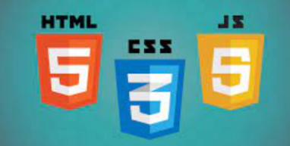  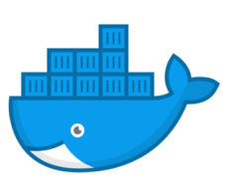 

### Software Description:

##### Overview of PHP;

PHP (recursive acronym for PHP : Hypertext Preprocessor) is a widely-used open source general-purpose scripting language that is especially suited for web development and can be embedded into HTML.

PHP is a server-side scripting language, especially suited for the creation of dynamic web pages. This programming language offers web developers a large selection of instruments. PHP, which has become the basis for many web applications, allows easy insertion in HTML code and connection to MYSQL and PgSQL Databases.

A PHP page must have a PHP-supported extension. Typically, a PHP file ends with .php, although other PHP extensions such as .php4 and .phtml also exist. However, .php is the most common extension.

* + 1. **PROCEDURES:**

### 

### To create a new PHP page

Do one of the following :

* + - * On the File menu, point to New, and then click PHP.
      * On the File menu, click New. In the New dialog box, on the Page tab, click General, then click PHP, and then click OK.

##### PHP script blocks

A PHP script block can appear anywhere in a .php page, and each page can contain more than one PHP script block. A PHP script block must begin with <?php and end with ?>.

The following is an example of a PHP script block:

<?php

echo "Hello World";

?>

### 

### Features of PHP:

* Loosely Typed Language : PHP supports variable usage without declaring its data type. It will be taken at the time of the execution based on the type of data it has on its value.
* Cross Platform Compatibility : It is used to create the desktop application by using advanced PHP features.
* variable variables : PHP allows changing the variable name dynamically by using variable variables.
* Real-Time Access Monitoring : PHP provides access logging by creating the summary of recent accesses for the user.
* Magic Method : PHP has built in methods starts with (double underscore). These methods can’t be called directly. Rather, it will be called on the event basis.

For example, clone() will be called, when the clone keyword is used.

* Error Reporting : It has some predefined error reporting constants to generate a warning or error notice.

For example, when E_STRICT is enabled, a warning about deprecated methods will be generated.

* Extended Regular Expression : PHP provides REGEX methods with extensive parsing and pattern matching mechanism with remarkable speed.
* nowdocs and heredocs String : PHP provides the *nowdocs* and *heredocs* properties are used to delimit some block of context. *nowdocs* and *heredocs* are same except the context in the heredocs allow variable parsing.
* Traits : PHP is a single inheritance language. The traits concept is used to cover inheritance limitation and support inheritance at multiple levels.

##### Advantages of the PHP software development technology

The main factor of the PHP language is the practicality. This programming language gives the possibility of realization tasks in short period and high quality for the developers. This point is based on the 5 features:

* Traditionality : PHP programming language is rather easy for the developers that work in different spheres. It is based on C and Perl that minimized efforts for learning the **PHP software development** and HTML5 mobile web development main elements and functions. Simplicity : The PHP script could consist of 10000 symbols or even from the one line - all depends on the project requirements and development purposes. There is no necessity for additional libraries download or specific compilation points mentioned.
* Effectiveness : The important advantage of the PHP language is its software engine. It is not just a compiler or interpreter, it is the relaying interpreter. Such structure of the software engine makes possible of high-speed script process.

### Security of PHP software development process

* Security : **PHP software development** process gets two security categories for developers and administrators: system-level services and application-level tools. System-level is guaranteed by the safe mode work type that limits the user’s possibilities in different points. Application-level is realized through the standard function set with the number of strong encryption mechanisms.
* Flexibility : **PHP software development** language is easy integrated with HTML, JavaScript, XML etc.

##### 

##### Advantages of PHP

* Open source : It is developed and maintained by a large group of PHP developers, this will helps in creating a support community, abundant extension library.
* Speed : It is relative fast since it uses much system resource.
* Easy to use : It uses C like syntax, so for those who are familiar with C, it's very easy for them to pick up and it is very easy to create website scripts.
* Stable : Since it is maintained by many developers, so when bugs are found, it can be quickly fixed.
* Powerful library support : You can easily find functional modules you need such as PDF, Graph etc.
* Built-in database connection modules : You can connect to database easily using PHP, since many websites are data/content driven, so we will use database frequently, this will largely reduce the development time of web apps.
* Can be run on many platforms, including Windows, Linux and Mac, it's easy for users to find hosting service providers.

##### 

##### Disadvantages of PHP

* Security : Since it is open sourced, so all people can see the source code, if there are bugs in the source code, it can be used by people to explore the weakness of PHP.

Not suitable for large applications: Hard to maintain since it is not very modular.

##### FRAMEWORK OF PHP:

PHP framework is a library that makes the life of site developer easier by for example hiding some complexities of HTTP protocol or by adding some useful functions. For example the **CakePHP** implements so called **MVC** which makes developer to think a level higher than HTTP.

##### USE OF FRAMEWORK:

The **MVC** Pattern. The Popular PHP frameworks like **CakePHP**, **CodeIgniter**, **Zend Framework**, **Symfony** follow **Model View Controller**(**MVC**) design pattern which separates business logic from user interface making the code cleaner and extensible.

##### Advantages of PHP Framework:

There have been multiple advantages of PHP framework, while developing a website with a PHP framework. Utilizing the PHP framework can encourage website developers to show their best efforts.

##### PHP framework inbuilt with robust functions:

This framework is built with an excellent set of functions, you can abridge tough tasks and get quick results from PHP coding. PHP framework is freeware with various functions; utilizing these functions you can simplify the code in PHP.

##### Centralized Database:

Database is the crucial factor for each project. It is the central point, where the entire data of the project are saved and called for, when required. MySQL is utilized for the database requirements for PHP.

##### Use wire-frame before coding:

It is always beneficial to use wire frame before you start coding in PHP. The practice of using wire-frame, boost your web development projects effectively. Make sure the wire-frame club and all its elements are integrated perfectly.

**Disadvantages of PHP Framework:** Everything has two aspects. So, PHP framework has also some disadvantages Let's have a brief look of the disadvantages of PHP framework.Poor error handling method:

PHP framework has a bad error handling method! It is not an proper solution for the PHP developers. Therefore, as a qualified PHP developer, you will have to overcome with it.

##### PHP is Unsecured:

It is an open source system, so anyone can see and change the source code! If any web developers, who have great idea and experience in bug finding in the code can exploit your coding practice.

##### Core PHP:

It is very basic **PHP**. It is used to create dynamic web pages. It works without any additional library.

**2.6. Docker:**

Docker is an open platform for developing, shipping, and running applications. Docker enables you to separate your applications from your infrastructure so you can deliver software quickly. With Docker, you can manage your infrastructure in the same ways you manage your applications. By taking advantage of Docker’s methodologies for shipping, testing, and deploying code quickly, you can significantly reduce the delay between writing code and running it in production.

## Child commands:

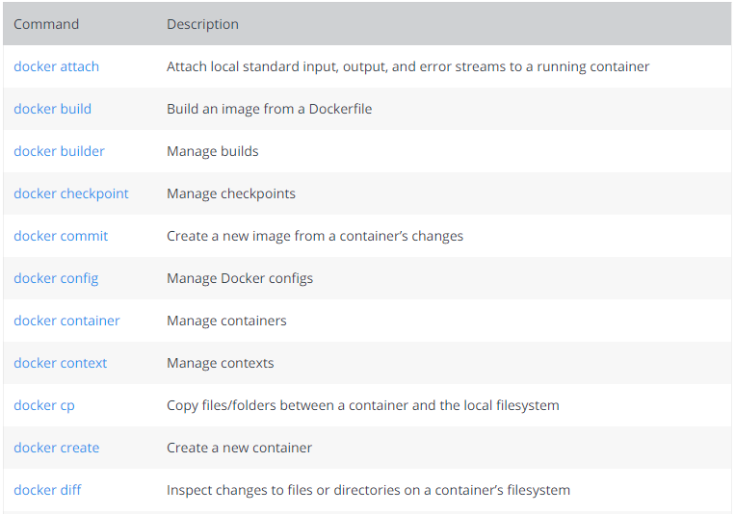

**2.7 JENKINS**

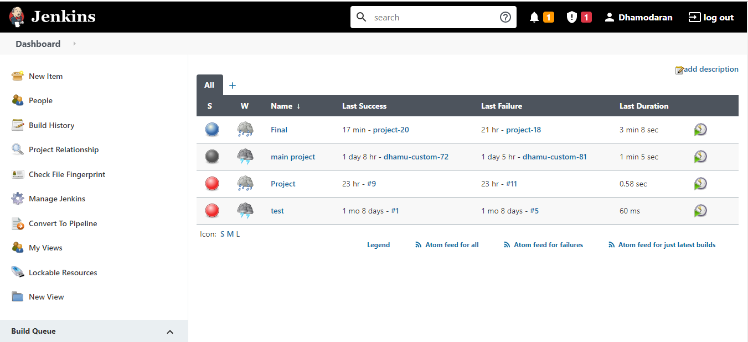

the Jenkins User Documentation contains a series of introductory tutorials to help you begin building your applications in an automated fashion with Jenkins.

If you’re a developer who wants to improve your understanding of Continuous Integration (CI) / Continuous Delivery (CD) concepts, or you might already be familiar with these concepts but don’t yet know how to implement them in Jenkins, then these tutorials are a great place to start.

PROJECT DESIGN

**Docker Architecture:**

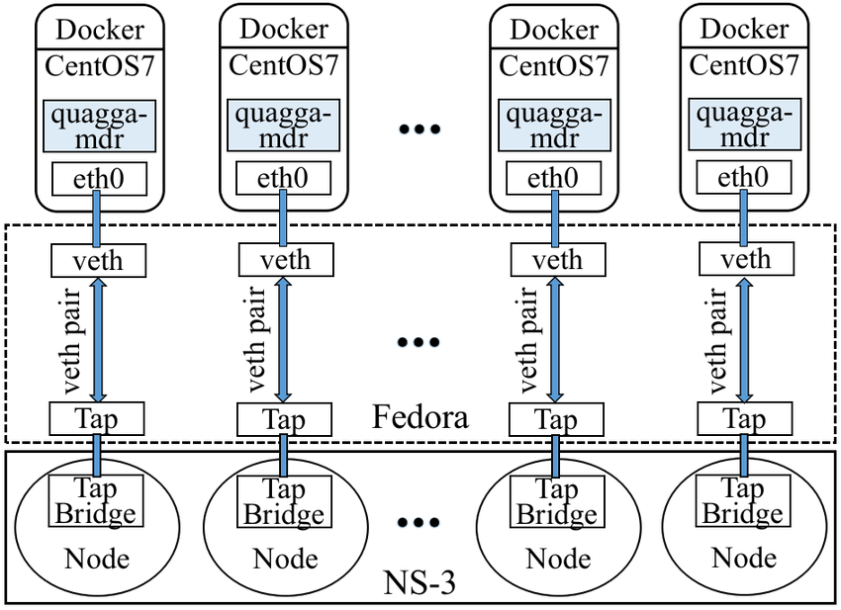

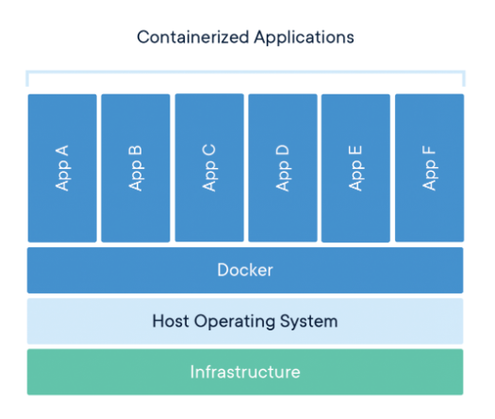

**Jenkins architecture :**

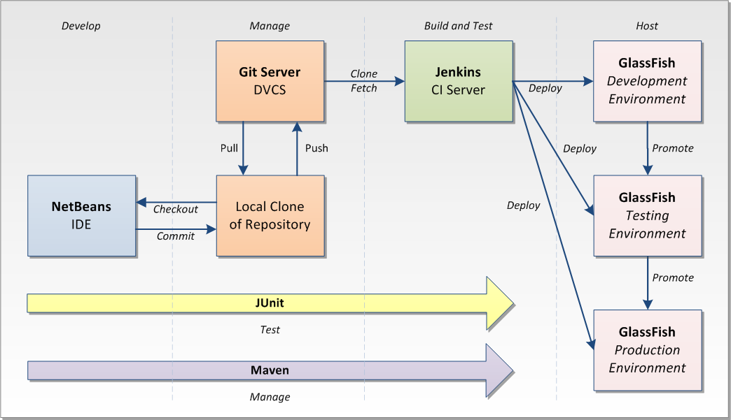

**FRONT DESIGN**

**Index.php**



**About.php**



**Services.php**

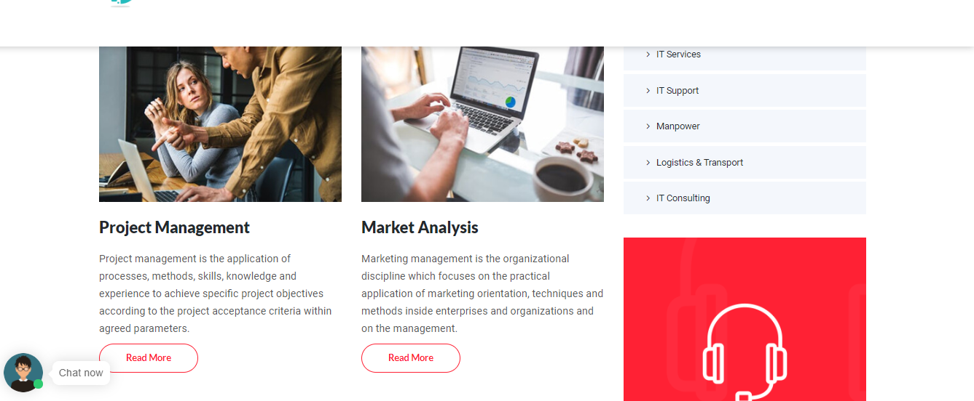

**Webdevelopment.php:**

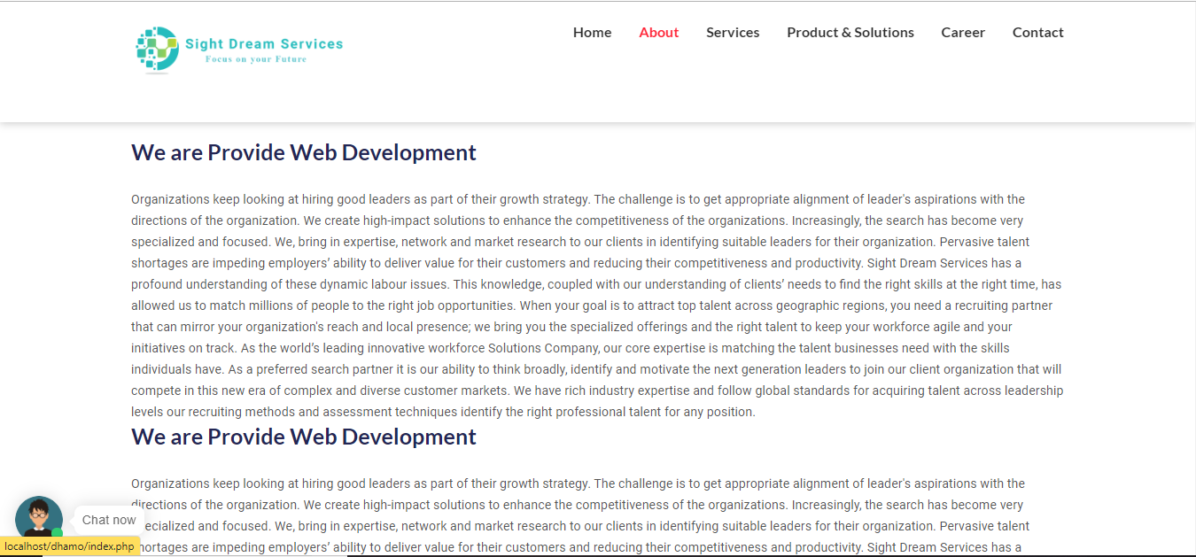

**Career.php:**

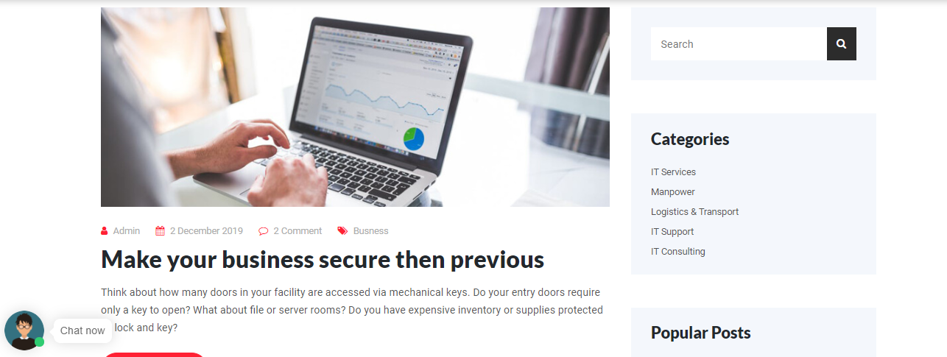

**Contact.php**

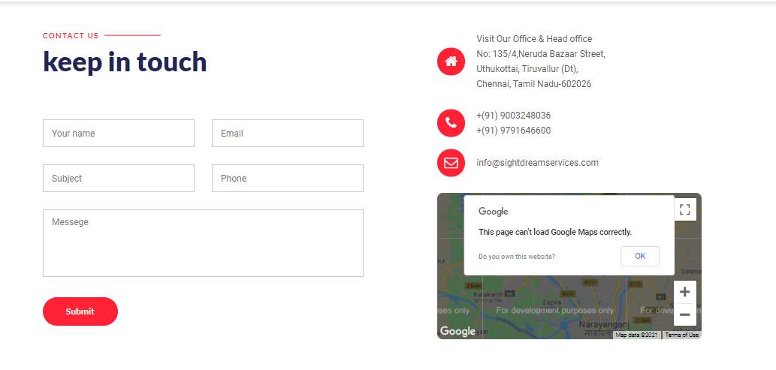

**CHATBOT:**

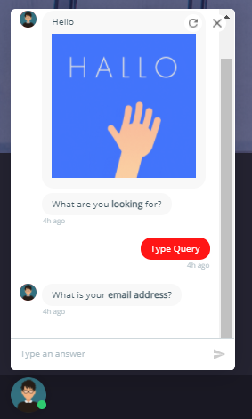

**Footer.php:**

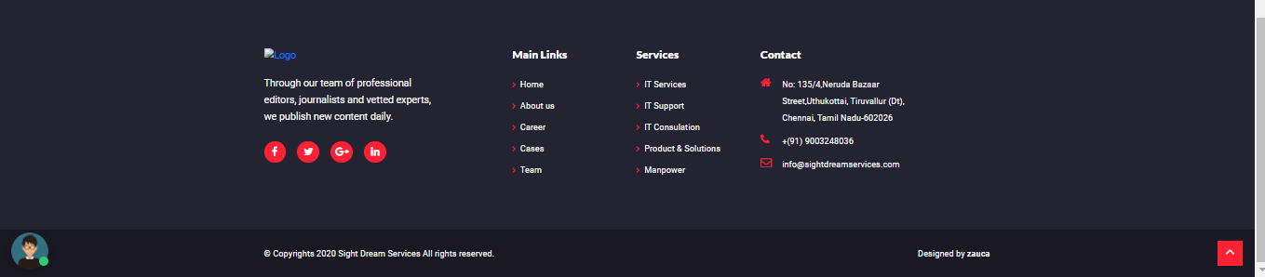

**Header.php:**

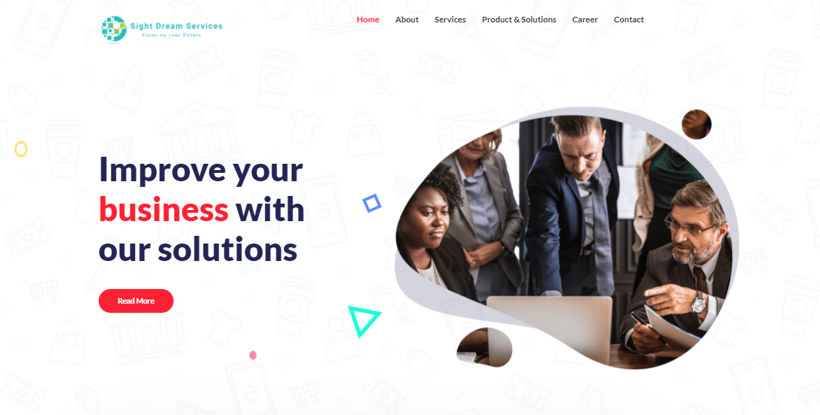

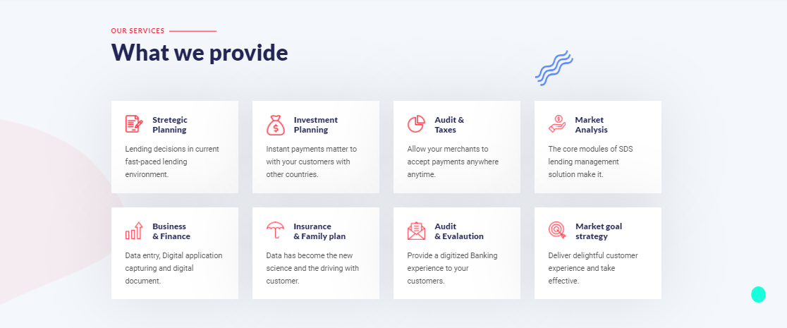

SOURCE CODE:

Header.php:

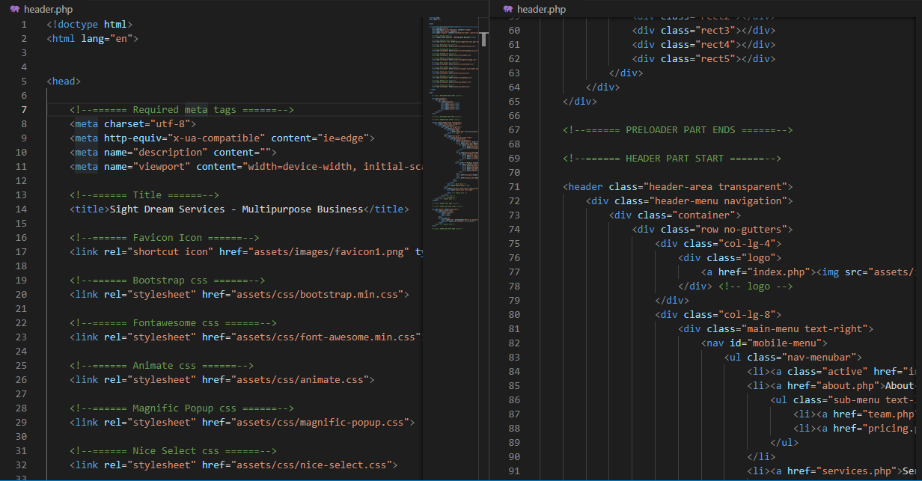

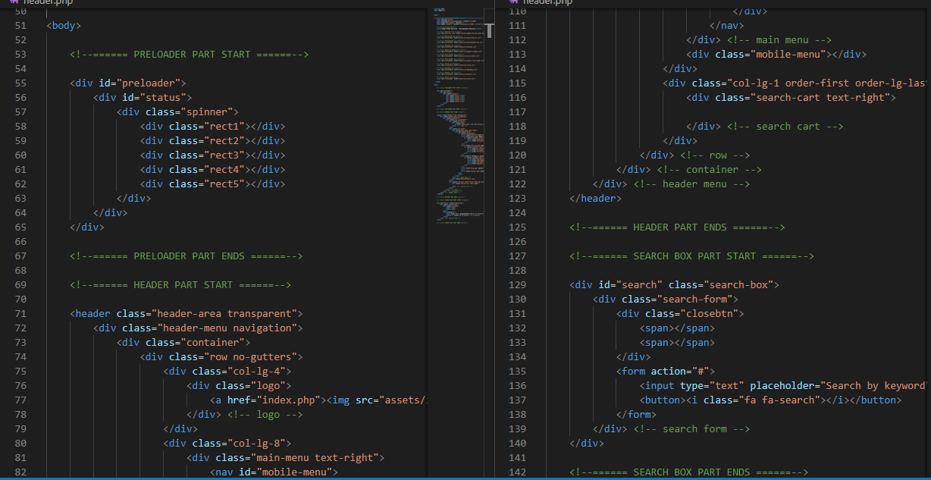

About.php:

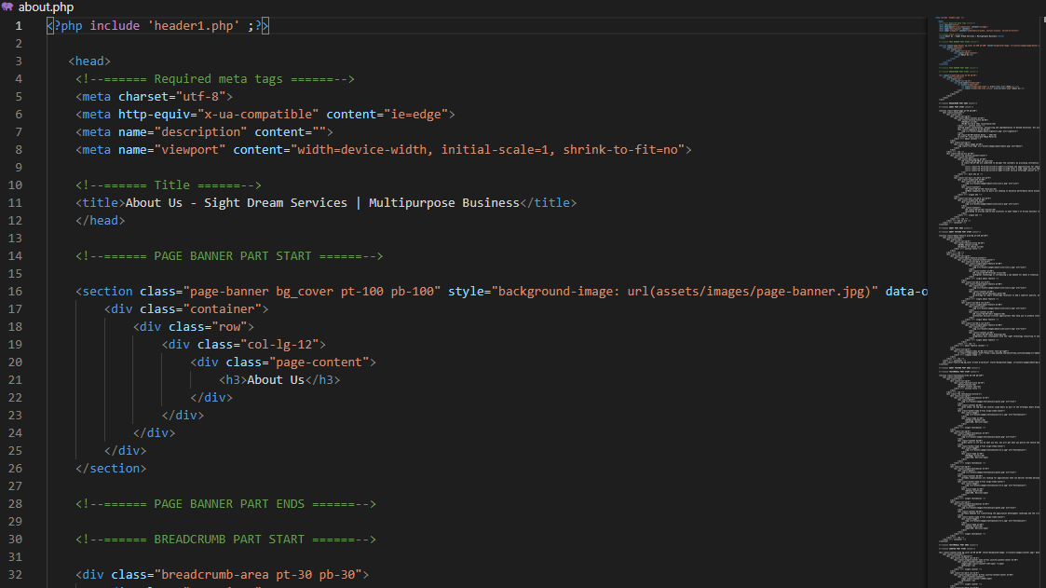

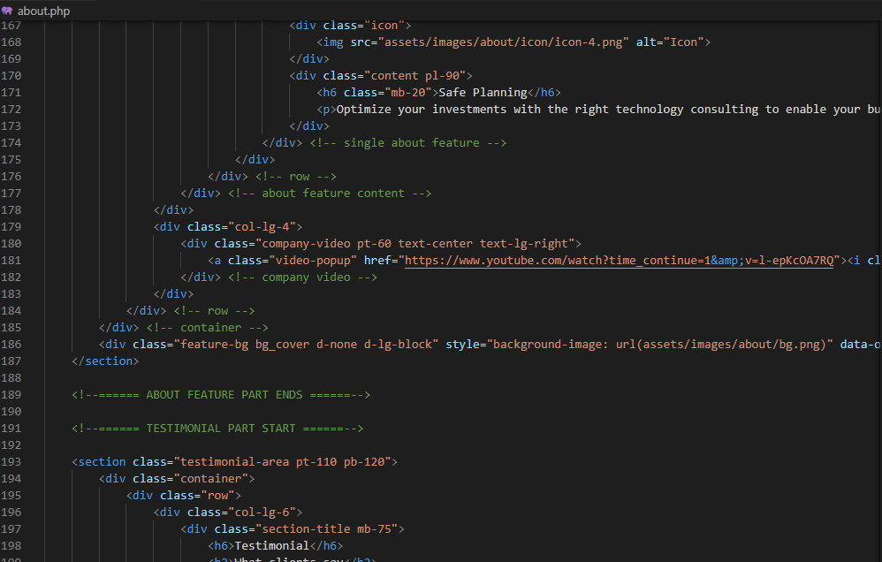

**INDEX.php:**

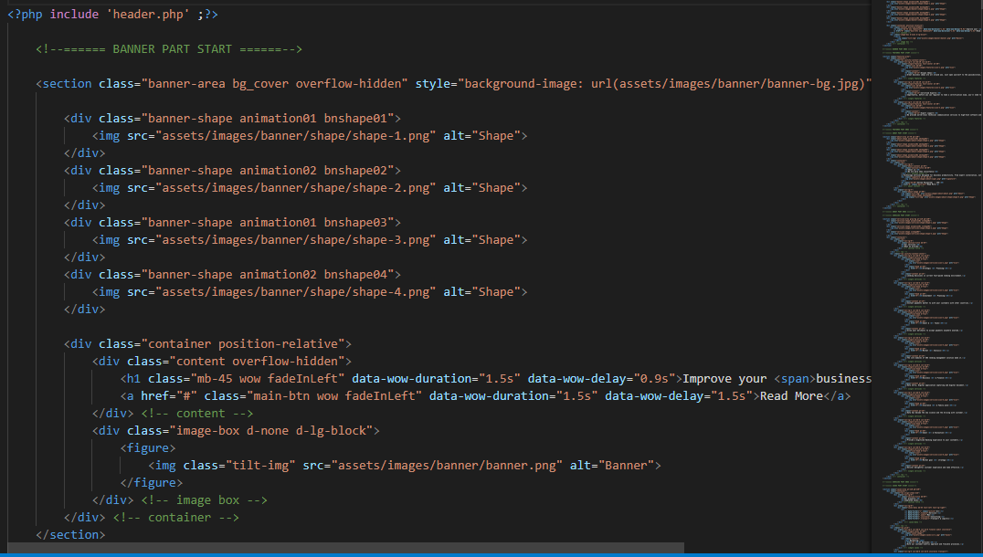

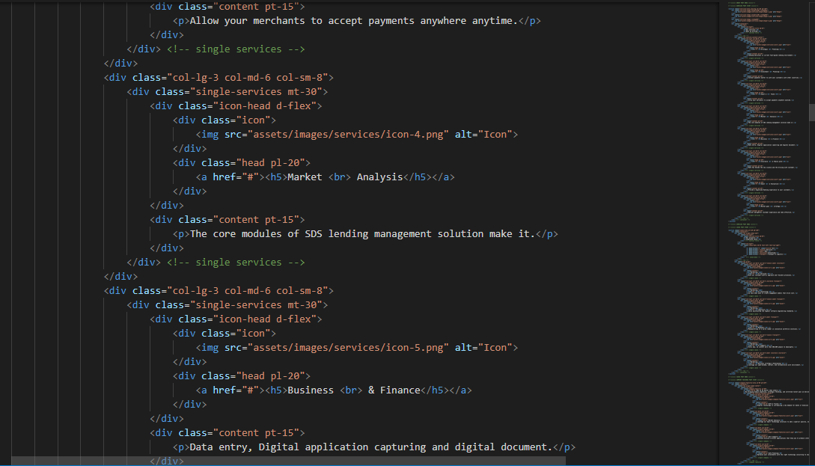

Footer.php:

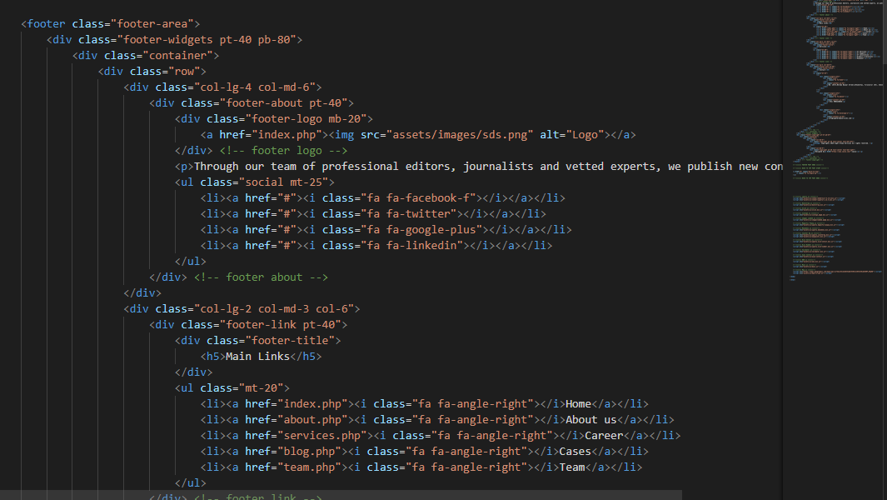

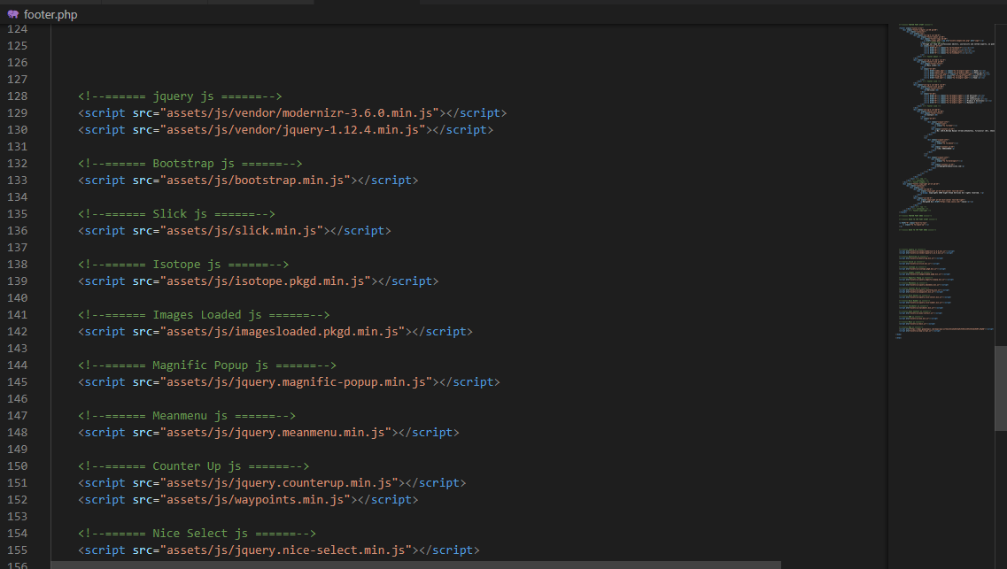

Contact.php:

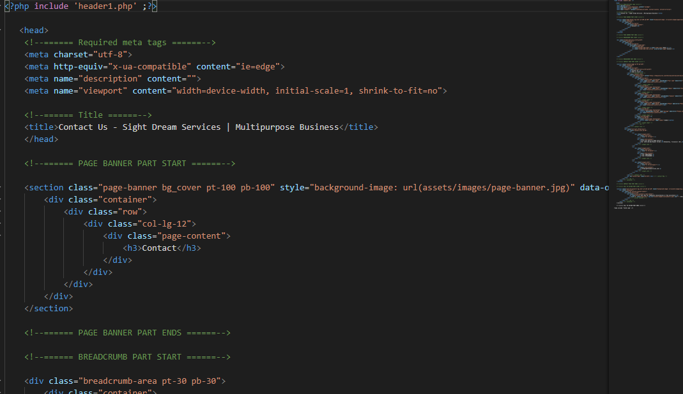

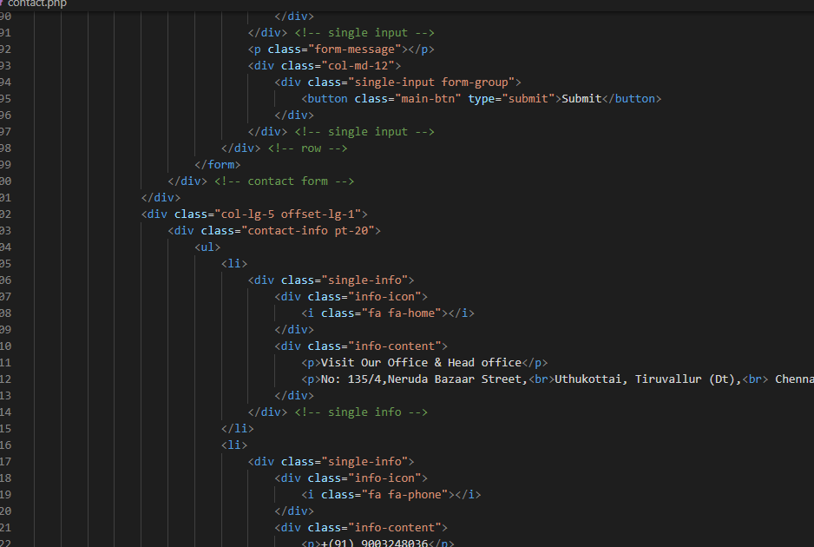

Pricing.php:

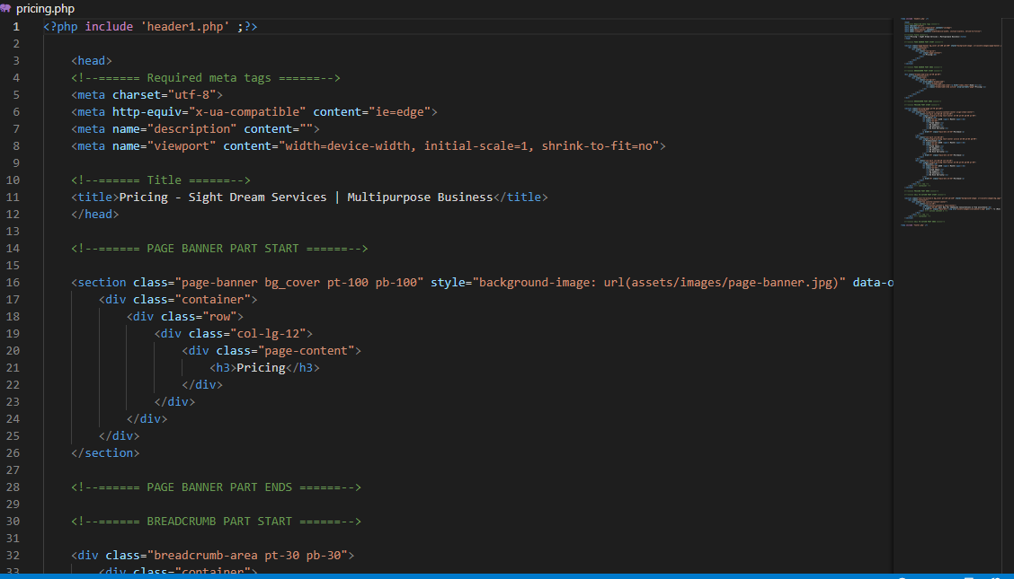

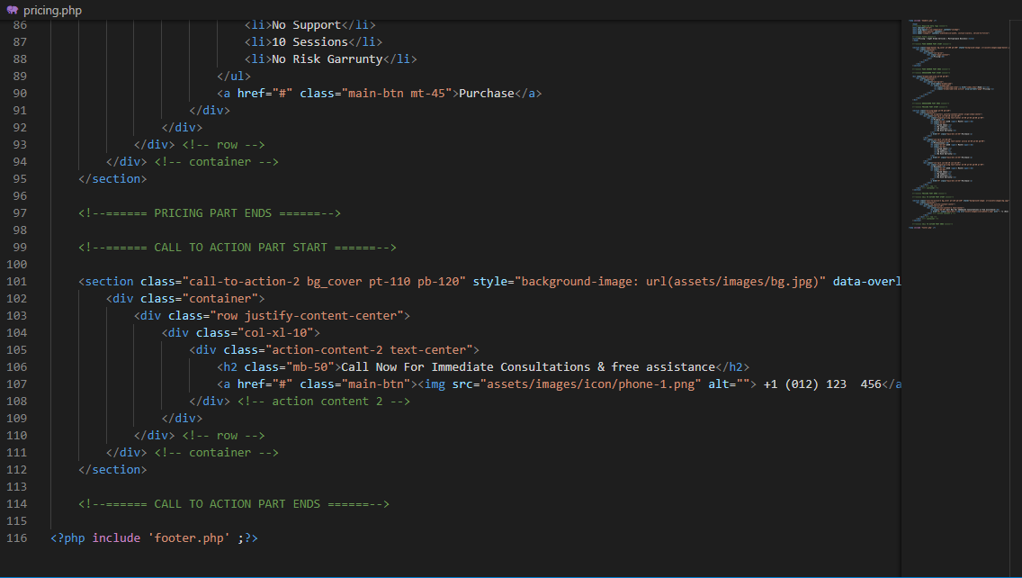

**IT-consult.php:**

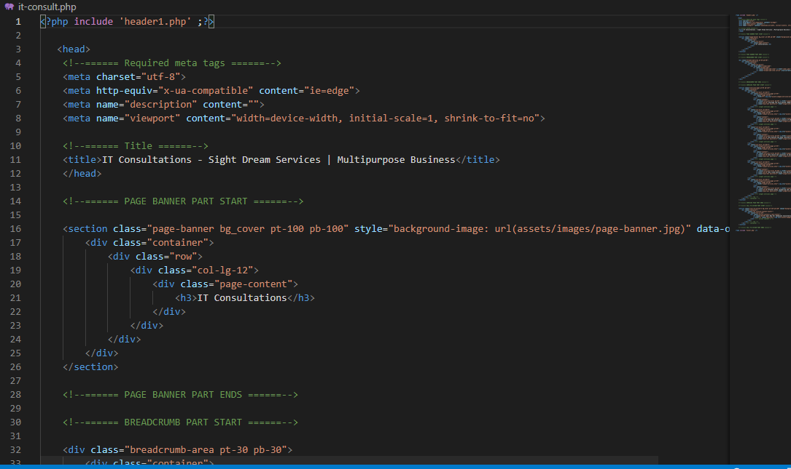

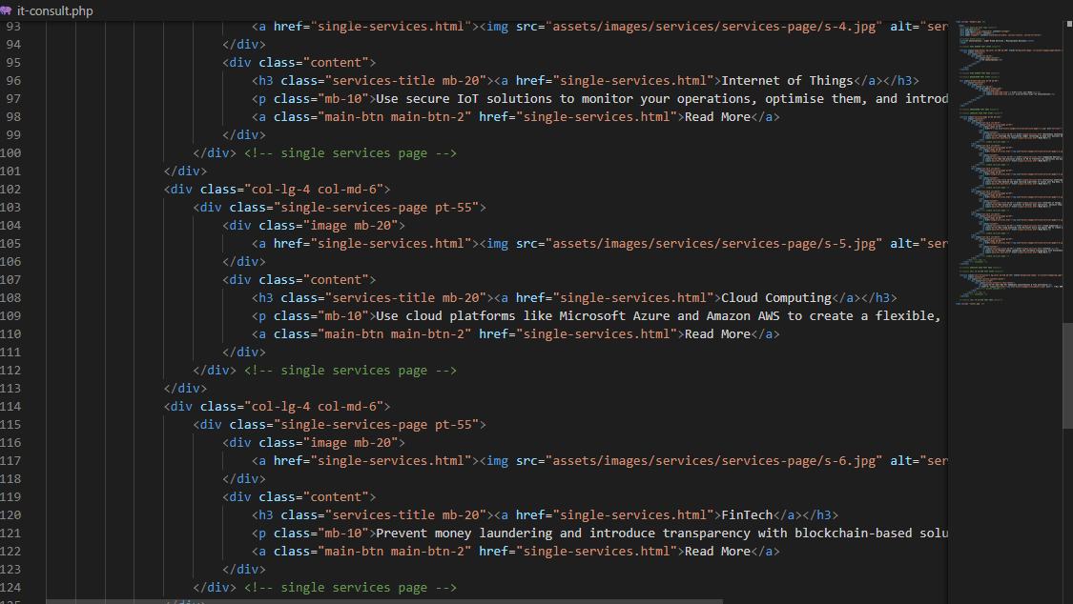

**It-service.php**

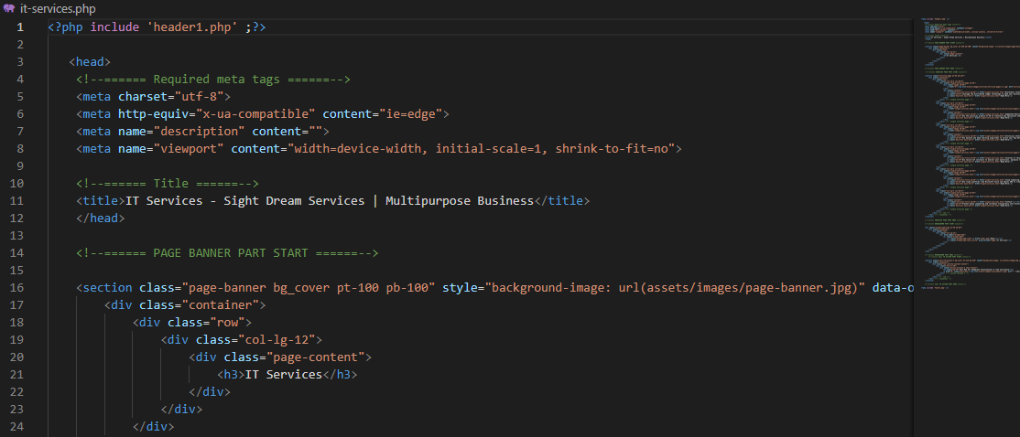

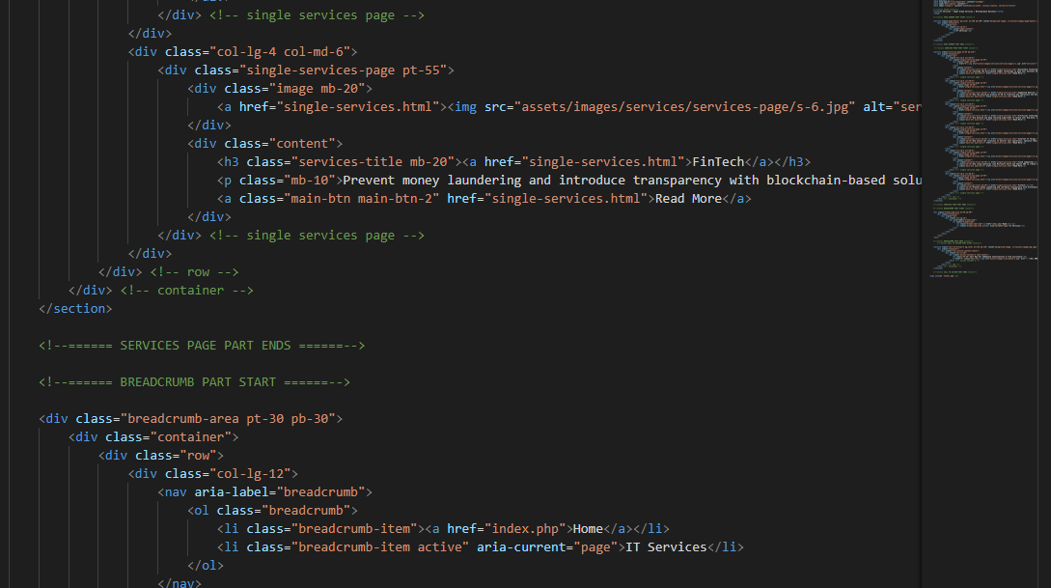

**IT-support.php:**

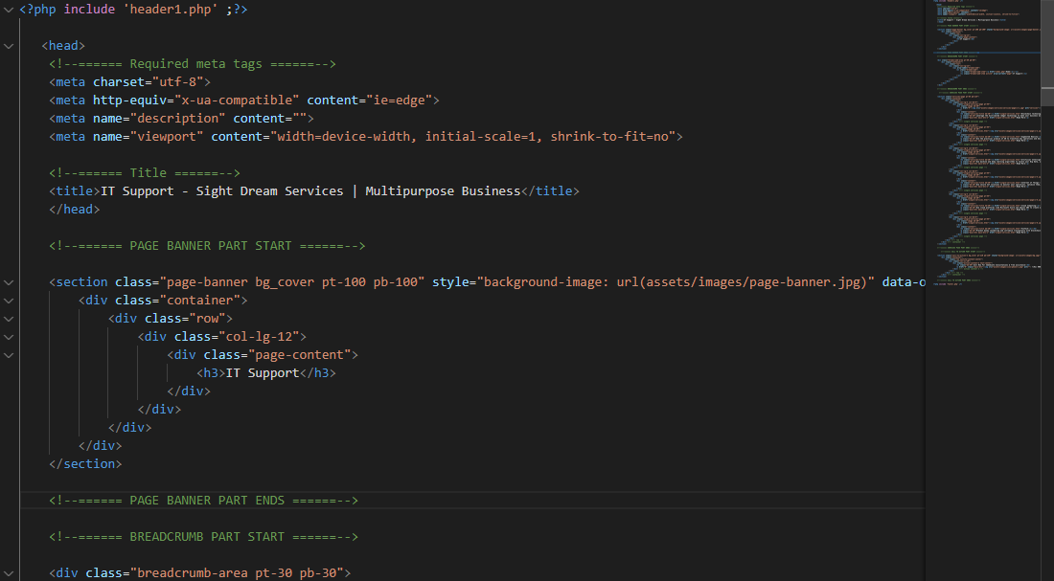

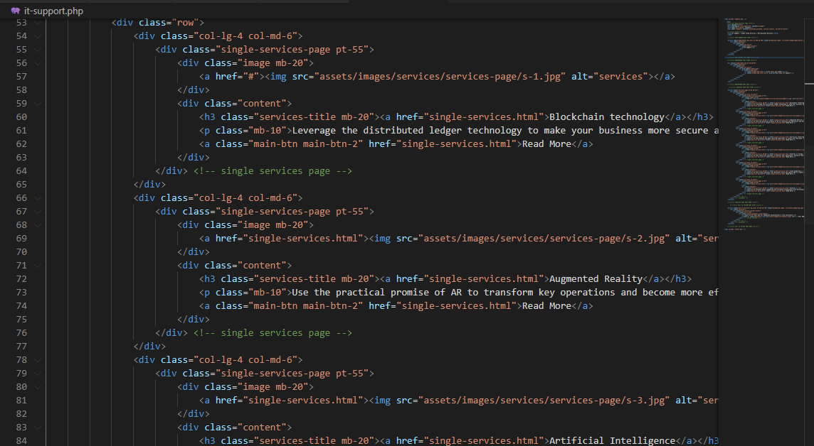

**Services.php**

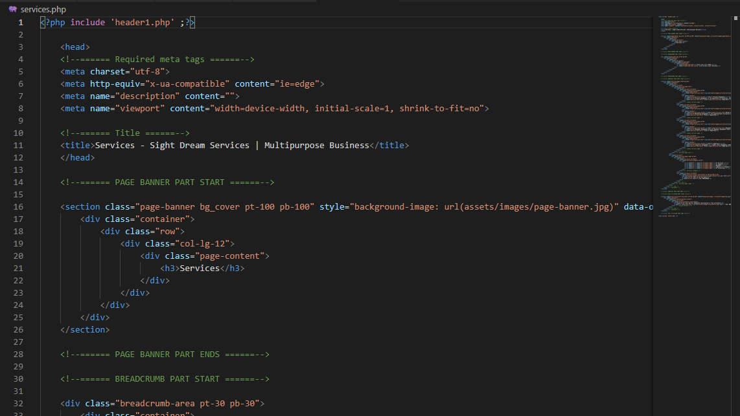

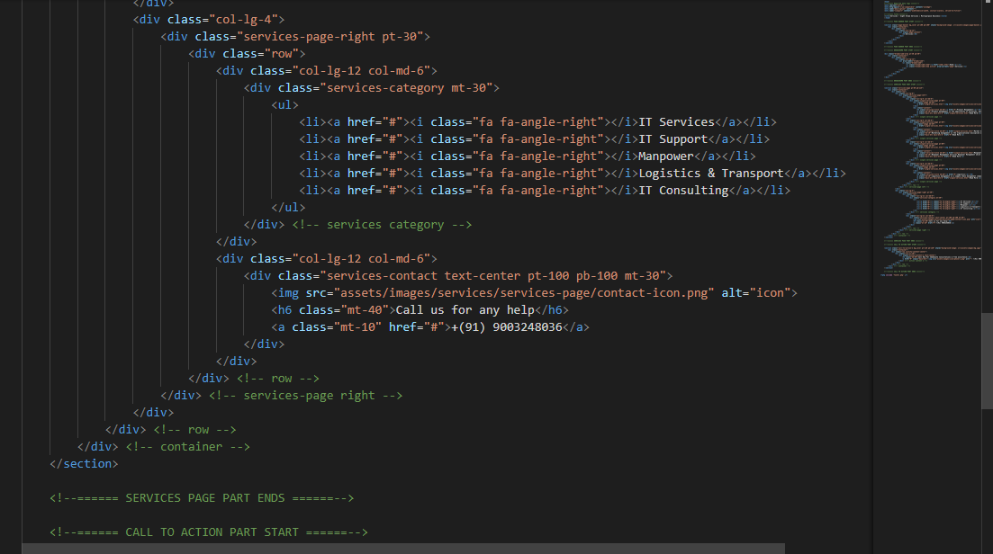

REPORT:

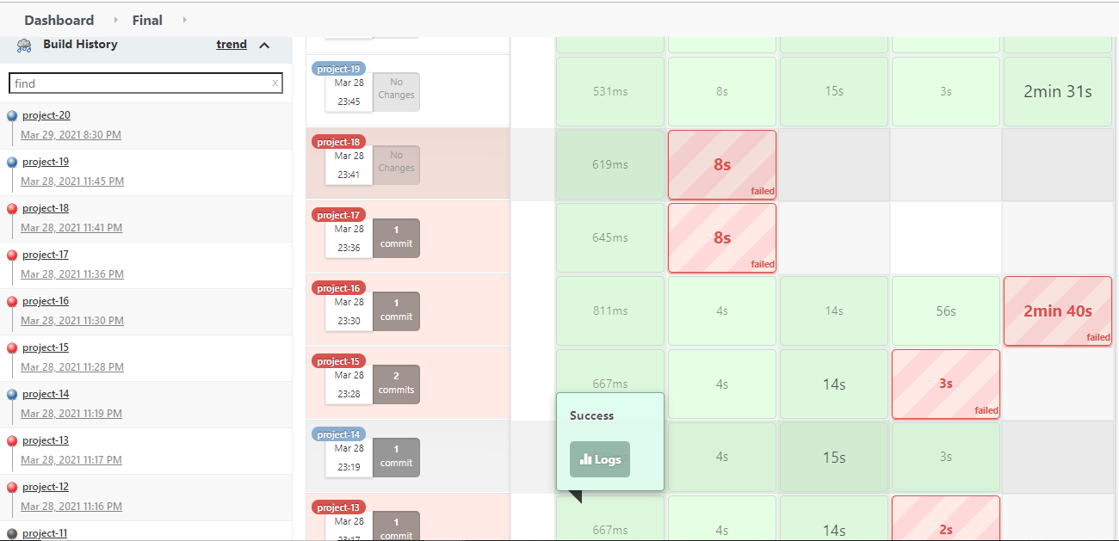

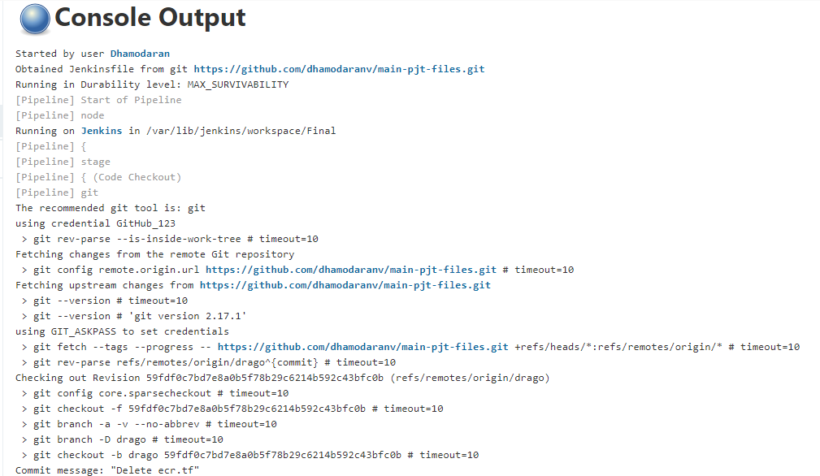

DEPLOY END:

##### AWS ECR:

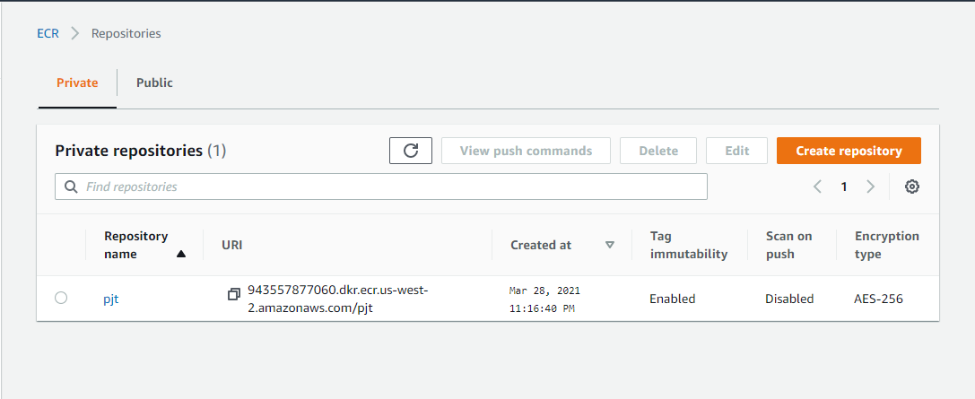

##### Clusters:

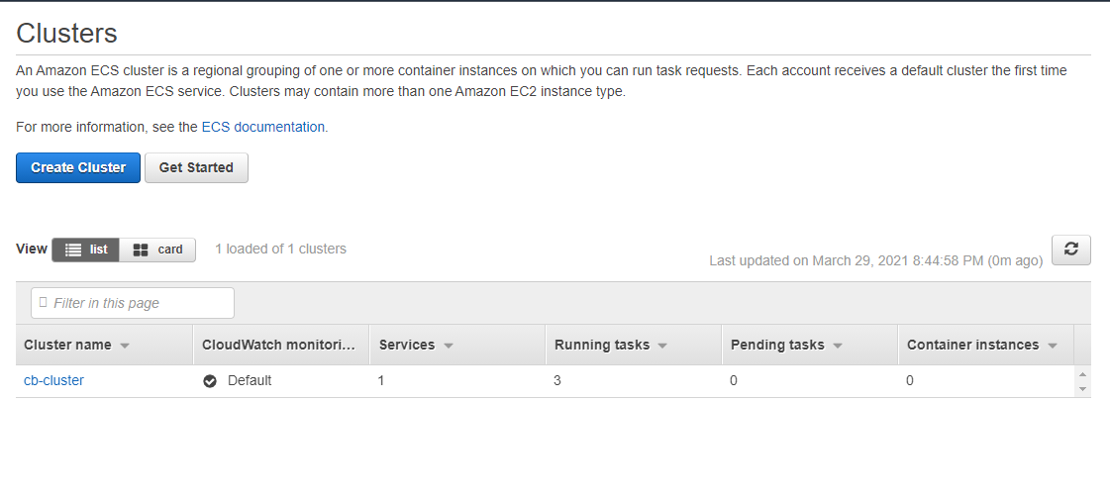

##### Jenkins dashboard:

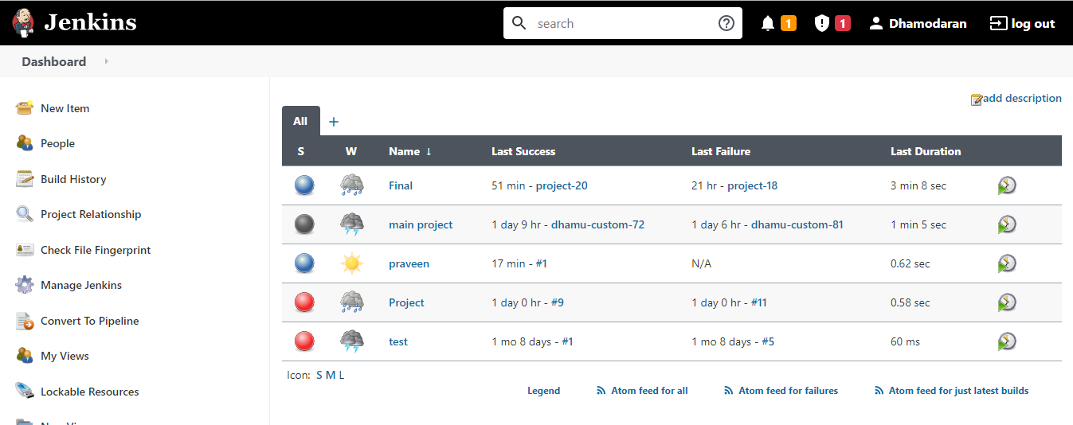

System Testing:

##### **SYSTEM TESTING**

**System testing** of software or hardware is testing conducted on a complete, integrated system to evaluate the system's compliance with its specified requriements. System testing falls within the scope of blackbox tesing and as such, should require no knowledge of the inner design of the code or logic.

As a rule, system testing takes, as its input, all of the "integrated" software components that have passed unit testing and also the software system itself integrated with any applicable hardware system(s). The purpose of integration testing is to detect any inconsistencies between the software units that are integrated together or between any of the *assemblages* and the hardware. System testing is a more limited type of testing; it seeks to detect defects both within the "inter- assemblages" and also within the system as a whole.

They performed on the entire system in the context of Functional

Requirements Specification(s) (FRS) and/or a System requirements Specification (SRS). System testing tests not only the design, but also the behaviour and even the believed expectations of the customer. It is also intended to test up to and beyond the bounds defined in the software/hardware requirements specification.

##### Basics of system testing

There are two basics of software testing: blackbox testing and whitebox testing.

##### Blackbox Testing :

Black box testing is a testing technique that ignores the internal mechanism of the system and focuses on the output generated against any input and execution of the system. It is also called functional testing.

##### Whitebox Testing:

White box testing is a testing technique that takes into account the internal mechanism of asystem. It is also called structural testing and glass box testing.

##### Types of testing

There are many types of testing like

Unit Testing Integration Testing Functional Testing System Testing Stress Testing Performance Testing Usability

Beta Testing

##### Unit Testing

Unit testing is the testing of an individual unit or group of related units. It falls under the class of white box testing. It is often done by the programmer to test that the unit he/she has implemented is producing expected output against given input.The design of the test cases the that validate that the internal program logic is function properly and the program gives the valid output . All decision branches and a internal code followed should be validated. It the testing of individual software units of the application is done after completion it individual unit before integration. This is structural testing, that relies on knowledge of its construction and its invasive. Unit tests performance basics test at component level and test a specific business process, application. and/or system configuration. Unit test ensure that each unique each path of a business process performs accurately to the documented specifications and contains clearly defined inputs and expected results.

##### Integration testing

Integration testing is testing in which a group of components are combined to produce output. Also, the interaction between software and hardware is tested in integration testing if software and hardware components have any relation. It may fall under both white box testing and black box testing.

##### Functional Testing

Functional testing is the testing to ensure that the specified functionality required in the system requirements works. It falls under the class of black box testing. This provide systematic Demostrations that functions are tested are available as specified by the business and technical requirements system documentation, and user manuals,

Functional testing is centered on the following items:

Valid Input : Identified classes of valid input must be accepted. Invalid Input : Identified classes of valid input must be rejected. Functions : Identified functions must be exercised.

Ouput: Identified classes of application must be exercised. System/Procedures : Interfacing system or procedures must be invoke.

**System Testing**

System testing is the testing to ensure that by putting the software in different environments (e.g., Operating Systems) it still works. System testing is done with full system implementation and environment. It falls under the class of black box testing.Its ensure that the entire integrated software system meets requirements . Its tests a configuration to ensure know and predictable results . An example of sytem testing is the configuration oriented system integrated test . They bsed on process description and flows,emphasizing pre-drive process links and integration points .

##### Stress Testing :

Stress testing is the testing to evaluate how system behaves under unfavorable conditions.

Testing is conducted at beyond limits of the specifications. It falls under the class of black box testing**.**Stress testing is the process of determining the ability of a computer, network, program or device to maintain a certain level of effectiveness under unfavorable conditions. The process can involve quantitative tests done in a lab, such as measuring the frequency of errors or

system crashes. The term also refers to qualitative evaluation of factors such as availability or resistance to denial-of-service (DoS) attacks. Stress testing is often done in conjunction with the more general process of performance testing. Stress testing is the process of determining the ability of a computer,network,program or device to maintain a certain level of effectiveness under unfavorable conditions. The process can involve quantitative tests done in a lab, such as measuring the frequency of errors or system crashes. The term also refers to qualitative evaluation of factors such as availability or resistance to denial-of-service (DoS) attacks. Stress testing is often done in conjunction with the more general process of performance testing .

When conducting a stress test, an adverse environment is deliberately created and maintained. Actions involved may include:

Running several resource-intensive applications in a single computer at the same time Attempting to hack into a computer and use it as a [zombie](http://searchmidmarketsecurity.techtarget.com/definition/zombie) to spread [spam](http://searchmobilecomputing.techtarget.com/definition/spam)

Flooding a [server](http://whatis.techtarget.com/definition/server) with useless [e-mail](http://searchmobilecomputing.techtarget.com/definition/e-mail) messages

Making numerous, concurrent attempts to access a single [Web site](http://searchsoa.techtarget.com/definition/Web-site)

Attempting to infect a system with viruses, Trojans, [spyware](http://searchsecurity.techtarget.com/definition/spyware) or other malware.

##### Performance Testing

Performance testing is the testing to assess the speed and effectiveness of the system and to make sure it is generating results within a specified time as in performance requirements. It falls under the class of black box testing.Performance testing, a non-functional testing technique performed to determine the system parameters in terms of responsiveness and stability under various workload. Performance testing measures the quality attributes of the system, such as scalability, reliability and resource usage.

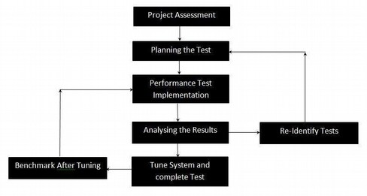

Performance Testing Techniques:

* **Load testing -**It is the simplest form of testing conducted to understand the behaviour of the system under a specific load. Load testing will result in measuring important business critical transactions and load on the database, application server, etc., are also monitored.
* **Stress testing -**It is performed to find the upper limit capacity of the system and also to determine how the system performs if the current load goes well above the expected maximum.
* **Soak testing -**Soak Testing also known as endurance testing, is performed to determine the system parameters under continuous expected load. During soak tests the parameters such as memory utilization is monitored to detect memory leaks or other performance issues. The main aim is to discover the system's performance under sustained use.
* **Spike testing -**Spike testing is performed by increasing the number of users suddenly by a very large amount and measuring the performance of the system. The main aim is to determine whether the system will be able to sustain the workload.

##### Usability Testing

Usability testing is performed to the perspective of the client, to evaluate is a technique used in user-centered interaction design to evaluate a product by testing it on users. This can be seen as an irreplaceable [usability](https://en.wikipedia.org/wiki/Usability) practice, since it gives direct input on how real users use the system.This is in contrast with [usability inspection](https://en.wikipedia.org/wiki/Usability_inspection) methods where experts use different methods to evaluate a user interface without involving users.

Usability testing focuses on measuring a human-made product's capacity to meet its intended purpose. Examples of products that commonly benefit from usability testing are foods, consumer\ products,web sites or web applications, computer interfaces, documents, and devices. Usability testing measures the usability, or ease of use, of a specific object or set of objects, whereas general [human-computer interaction](https://en.wikipedia.org/wiki/Human-computer_interaction) studies attempt to formulate universal principles.

##### Acceptance Testing :

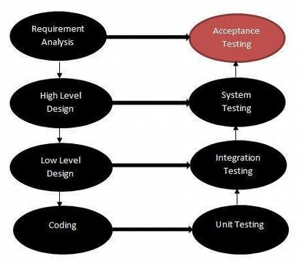Acceptance testing is often done by the customer to ensure that the delivered product meets the requirements and works as the customer expected. It falls under the class of black box testing. Acceptance testing, a testing technique performed to determine whether or not the software system has met the requirement specifications. The main purpose of this test is to evaluate the system's compliance with the business requirements and verify if it is has met the required criteria for development of users .

The acceptance test cases are executed against the test data or using an acceptance test script and then the results are compared with the expected ones.

Acceptance Criteria

Acceptance criteria are defined on the basis of the following attributes Functional Correctness and Completeness

Data Integrity Data Conversion Usability Performance Timeliness

Confidentiality

Availability Installability and Upgradability Scalability

Documentation

##### Acceptance Test Plan -Attributes

The acceptance test activities are carried out in phases. Firstly, the basic tests are executed, and if the test results are satisfactory then the execution of more complex scenarios are carried out.

The Acceptance test plan has the following attributes: Introduction

Acceptance Test Category operation Environment Test case

Test Title

Test Objective Test Procedure Test Schedule Resources

The acceptance test activities are designed to reach at one of the conclusions: Accept the system as delivered

Accept the system after the requested modifications have been made Do not accept the system

Acceptance Test Report - Attributes

The Acceptance test Report has the following attributes: Report Identifier

Summary of Results Variations Recommendations Summary of To-DO List Approval Decision

##### Regression Testing

Regression testing is the testing after modification of a system, component, or a group of related units to ensure that the modification is working correctly and is not damaging or imposing other modules to produce unexpected results. It falls under the class of black box testing.

Regression testing is the process of testing changes to computer programs to make sure that the older programming still works with the new changes. Regression testing is a normal part of the program development process and, in larger companies, is done by code testing specialists. Test department coders develop code test scenarios and exercises that will test new units of code after they have been written. These test cases form what becomes the *test bucket*. Before a new version of a software product is released, the old test cases are run against the new version to make sure that all the old capabilities still work. The reason they might not work is because changing or adding new code to a program can easily introduce errors into code that is not intended to be changed.

##### Beta Testing

Beta testing is the testing which is done by end users, a team outside development, or publicly releasing full pre-version of the product which is known as beta version. The aim of beta testing is to cover unexpected errors. It falls under the class of black box testing.In a test is the second phase of software testing in which a sampling of the intended audience tries the product out.

This test is also sometimes reffered to as user acceptance testing(UAT) or end user testing. In this phase of software development,applications are subjected to rel world testing by the intended audience for the software. The experiencesof the early users are forwarded back to the developers make final changes before relasing the software commercially.

**CONCLUSION:**

The Application Deployment On AWS ECS Service Using CI/CD Tool was developed using JENKINS, DOCKER, GitHub, TerraForm.

This module gave a fundamental understanding of the models that were introduced in the first course of this series,  as a way of making the complex concepts of Web development concrete.  
In addition, it is hoped that Web Team continues to put a human face on the Web development process.

**BIBLIOGRAPHY:**

CODE REFERENCE:

Jenkins:

<http://54.212.62.28:8080/job/Final/20/console>

Github:

<https://github.com/dhamodaranv/main-pjt-files/tree/drago>

AWS:

<https://us-west-2.console.aws.amazon.com/ec2/v2/home?region=us-west-2#LoadBalancers:sort=loadBalancerName>